

**CAPSTONE PROJECT 1**

**Roomy-Accommodation Find System**

**Breaking Story into Tasks**

Version 1.0

Date: Sep 2nd, 2017

**MENTOR** **: MSc, Phan Van Son**

**PROJECT TEAM** : **Blue team**

**TEAM’S MEMBER** : Huynh Quoc Nhat

Ho Trung Anh

Le Hoang Quoc

Huynh Vu Ha Lan

Huynh Thi Thanh Van

**INTERNATIONAL SCHOOL**

**Project Information**

|  |  |  |  |  |  |
| --- | --- | --- | --- | --- | --- |
| **Project acronym** | Rommy | | | | |
| **Project Tittle** | Accommodation Find System | | | | |
| **Start Date** | Aug 01, 2017 | | **End Date** | | Dec 2, 2017 |
| **Lead Institution** | International School, Duy Tan University | | | | |
| **Project Mentor & contact details** | Msc. Son, Phan Van  Email:  Tel: | | | | |
| **Scrum Master & contact details** | Lan, Huynh Vu Ha  Email: [nguyenthanhhuy155@gmail.com](mailto:nguyenthanhhuy155@gmail.com)  Tel: 0989342173 | | | | |
| **Team members** | **Name** | **Email** | | **Tel** | |
| Nhat, Huynh Quoc Nhat |  | |  | |
| Anh, Ho Trung |  | |  | |
| Quoc, Le Hoang |  | |  | |
|  | Van, Huynh Thi Thanh |  | |  | |

**Breaking Story into Tasks Document**

|  |  |  |  |
| --- | --- | --- | --- |
| **Document Title** | Breaking Story Document |  |  |
| **Reporting Period** | August, 2017 |  |  |
| **Author(s) &**  **project** | Lan, Huynh Vu Ha,  Scrum Master | |  |
| **Team Information** | **Name** | **Role** |  |
| Nhat, Huynh Quoc Nhat | Member |  |
| Anh, Ho Trung | Member |  |
| Quoc, Le Hoang | Member |  |
|  | Van, Huynh Thi Thanh | Member |  |
| **Date** |  | **Filename** |  |
| **Access** | Project and CMU Program | |  |

|  |  |  |
| --- | --- | --- |
| Document History | | |
| **Version** | **Date** | **Comments** |
| V1.0 |  |  |
| V1.1 |  |  |

**Document Approvals**

The following signatures are required for approval of this document.

|  |  |  |
| --- | --- | --- |
| MSc. Son, Phan Van  *Mentor* |  |  |
| Lan, Huynh Vu Ha  *Scrum Master* |  |  |

Table of Contents

1. BREAKING STORY INTO TASKS 6

1.1. User story S.1: Login 6

1.2. User story S.2: View Information 6

1.3. User story S.3: Delete Information 6

1.4. User story S.4: View transaction history 7

1.5. User Story S.5: Classify customer 7

1.6. User story S.6: Register account 7

1.7. User story S.7: Update information account 8

1.8. User story S.8: View information business 8

1.9. User story S.9: Confirm registration information 9

1.10. User story S.10: Post approved 9

1.11. User story S.11: classification transactions 9

1.12. User story S.12: View transaction history 10

1.13. User story S.13: Find Product 10

1.14. User story S.14: Comment/Vote 10

1.15. User story S.15: View history of a post 11

1.16. User story S.16: View leads 11

1.17. User story S.17: Manage post on services/products 12

1. **BREAKING STORY INTO TASKS**

**Home Page**

## **User story S.1: Login**

|  |
| --- |
| Login |
| Input username and password  Read username and password from database  Compare username and password  If correct  Display home page  Else  Display Incorrect username or password message box. |

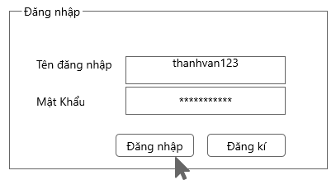

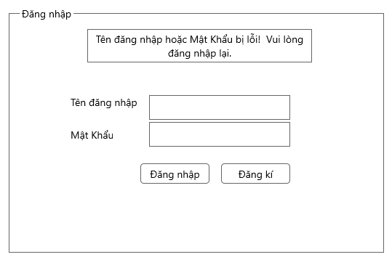

## **User story S.2: Register**

|  |  |
| --- | --- |
| Register 1 |  |
| If the first time users use the system, they can register by clicking on the registration button of the system and registration frame will appear.  Enter username, password, email and phone number.  Click button “Đăng ký”  Notify the user of successful registration | |

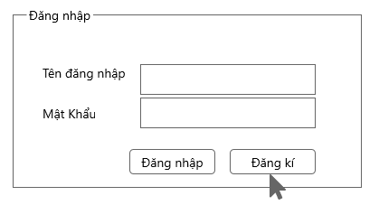

|  |
| --- |
| Register 2 |
| After clicking on the registration button, the user fill enough information in the form:  -“Tên đăng nhập”: The user enters the name that they want to use in the system. That does not match the name that exists in the system, does not contain special characters and spaces.  password: user enter password for login. That password does not contain special characters, space, password can not be less than 6 characters  - "Email" users enter their email. Email must conform to convention ten_e_mail@x_mail.com  - "Số điện thoại:" the user enters a phone number whose phone number contains only the number, the telephone number must not exceed 15 characters.  The user press the register button  If one of the 4 fields is entered incorrectly, the message will appear to be unsuccessful  Else announces successful registration |

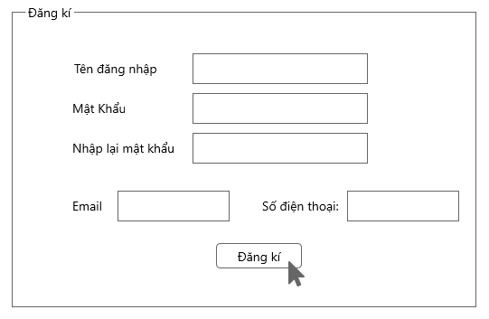

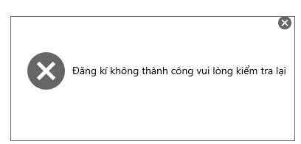

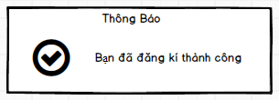

## **User story S.3: View Information**

|  |  |
| --- | --- |
| View Information |  |
| Select “Quản lý tài khoản” and click “Thông tin cá nhân” to view the information of user.  This button is on menu of website. It will show a page “Thông tin cá nhân”.  This functions let user view information user in the system. | |

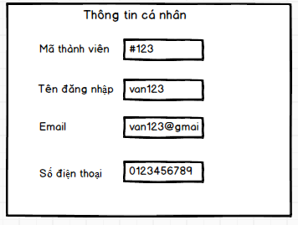

## **User story S.4: Update Information**

|  |  |
| --- | --- |
| Update Information |  |
| When user want to change information then they select " Cập nhật thông tin" and form "Cập nhật thông tin" will display and user can change email, phone number, password.  After the user has finished update their information, click the "Cập nhật" button so the system can change their information | |

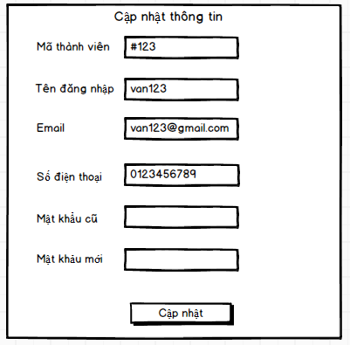

## **User story S.6: Searching information about accommodation**

|  |  |
| --- | --- |
| Searching information about accommodation |  |
| As Landlord, Renter  Select the category: type accomodation, province, district, price, area and select the "Search" button to show the location information user want to search. The accommodation will be displayed on the map at that location as well as the system will suggest some other nearby places | |

## 

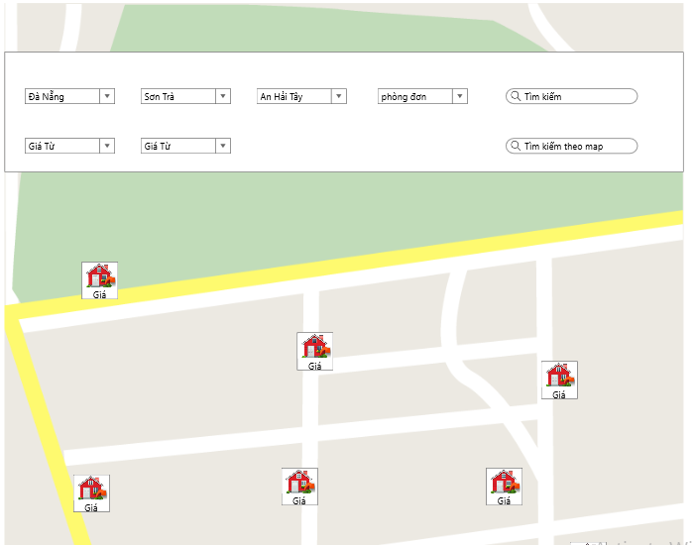

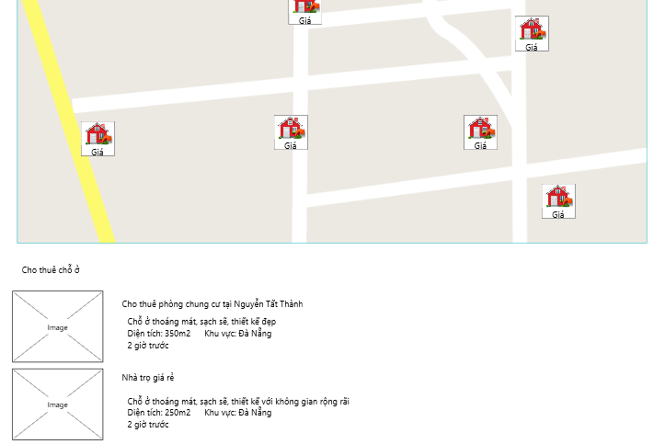**1.6 User story S.7: Manage Accommodation**

|  |  |
| --- | --- |
| Manage Accommodation |  |
| As Landlord  When the user clicks on "Quản lý chỗ ở", the form will be displayed, including: “Khu”, “Loại phòng”,”Tình trạng” include: "Phòng được thuê đang thuê", "Phòng còn trống", “Không hoạt động”, “Đang hoạt động”. Then the Landlord could see the whole interface so that they could manage their zone as well as their accommodation in a convenient way. | |

## 

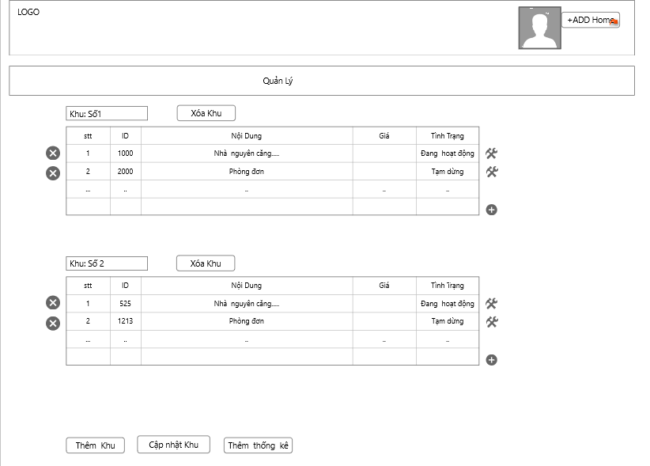

## **User story S.8: Add Zone**

|  |  |
| --- | --- |
| Add Zone |  |
| If Landlord want to add a new area, click button "Thêm Khu" in form “Quản lý chỗ ở”. Form "Thêm Khu" will be displayed. User complete full fields: "Khu", "Loại Phòng", "Số nhà và tên đường", "Thành phố", "Quận/ Huyện", "Xã/ Phường", "Diện Tích". After when complete full information , User click on the node "Thêm Khu", the screen will show message box to notice "Bạn đã thêm khu thành khu". | |

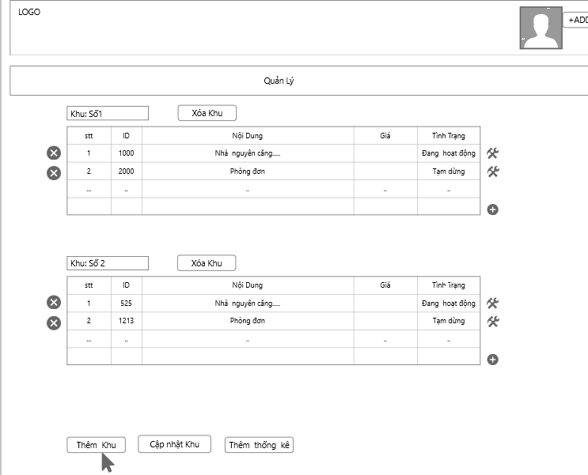

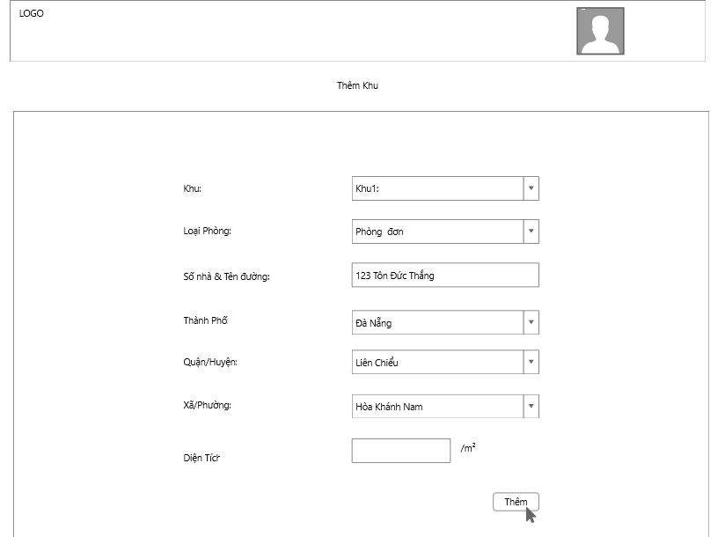

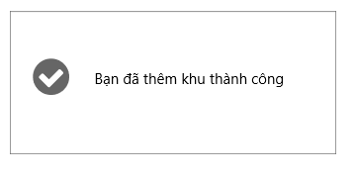

## **User story S.9: Update Zone**

|  |  |
| --- | --- |
| Update Zone |  |
| If Landlord want to add a new zone, click button "Cập nhật khu". Form "Thêm Khu" will be displayed. User complete full fields: "Khu", "Loại Phòng", "Số nhà và tên đường", "Thành phố", "Quận / Huyện", "Xã/ Phường", "Diện Tích". After when complete full information, User click on the node "Cập nhật" and Form report will show and message "Bạn đã cập nhật thành công". | |

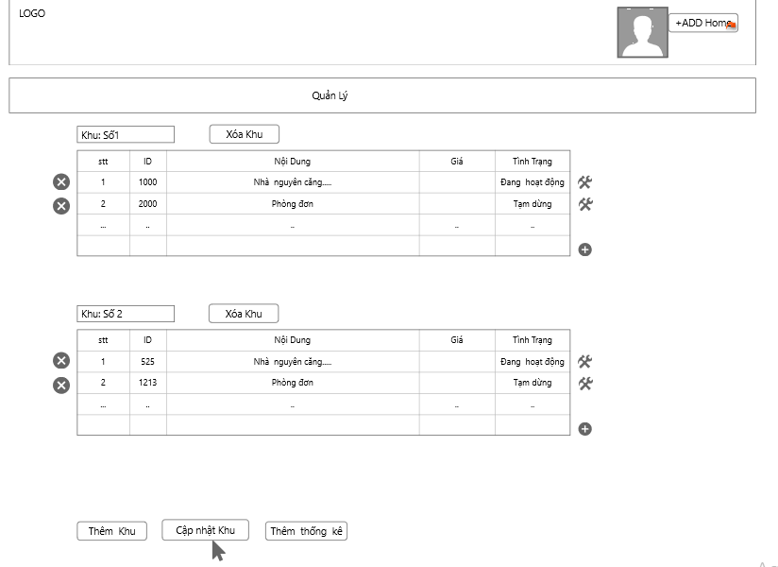

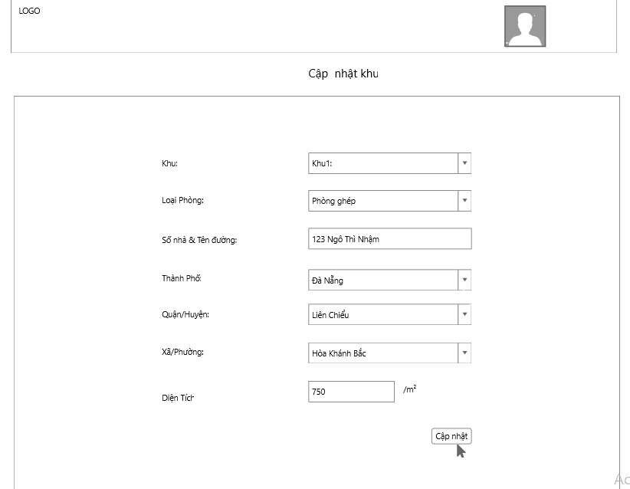

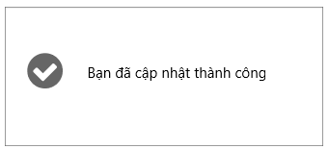

* 1. **User story S.10: Add Room**

|  |  |
| --- | --- |
| Add Room |  |
| During, the Landlord's wish to add a room to a particular area, the user clicks the "Thêm phòng" button, then the "Thêm Phòng" form displays includes the fields "Tên phòng", "Mô tả", "Loại", "Tình trạng", "Vị trí", "ID phòng", "Giá", “Hình ảnh", “Các tính năng” .Users must fill out all fields  If:  Users who do not fill out the information will display the message "Thêm phòng bị lôi"  else  "Thêm phòng thành công" | |

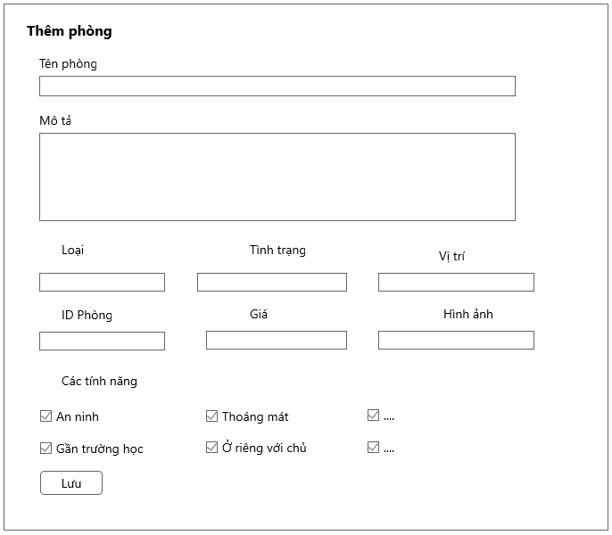

* 1. **User story S.11: Update Room**

|  |  |
| --- | --- |
| Update Room |  |
| During, the Landlord's wish to add a room to a particular area, the user clicks the "Cập nhật phòng" button, then the "Cập nhật phòng" form displays includes the fields "Tên phòng", "Mô tả", "Loại", "Tình trạng", "Vị trí", "ID phòng", "Giá", “Hình ảnh", “Các tính năng” .Users must fill out all fields  If:  Users who do not fill out the information will display the message  "Cập nhật không thành công"  else  “Cập nhật thành công” | |

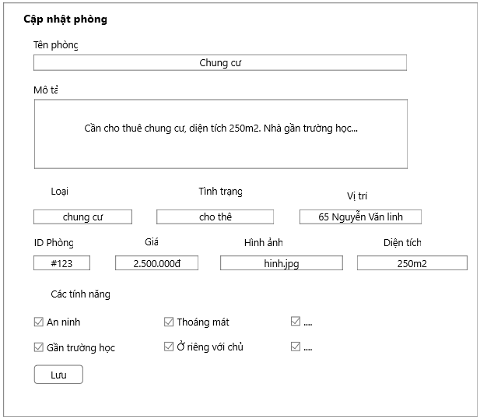

* 1. **User story S.12: Delete Room**

|  |  |
| --- | --- |
| Delete Room |  |
| The Landlord wants to delete a room when the room is no longer active, click on the "X" button, the message form will appear. It will ask the landlord, "Do you want to delete the room?"  If the Landlord wants to delete, click on "Yes" immediately the room will be deleted  else  The room remains the same | |

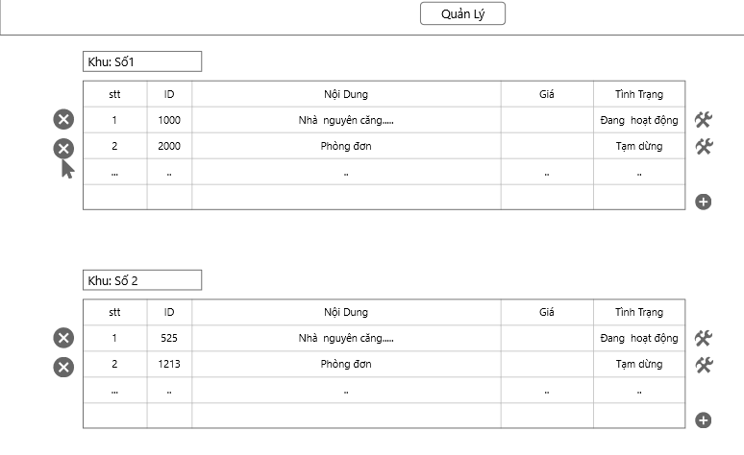

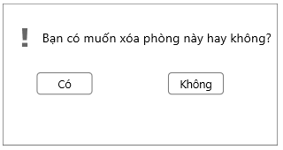

* 1. **User story S.13: Report for admin about accommodation**

|  |  |
| --- | --- |
| Report for admin about accommodation |  |
| As Renter  In the process the renter knows the person who posted the untrue with the post. The tenant will report by: Click on that post, in the post will have reported to the admin. The tenants only need to choose the case they want to report as: "False Information", "There are Tenants", ... and choose "Submit" then the report will be sent to admin so they can review this article need to be taken down | |

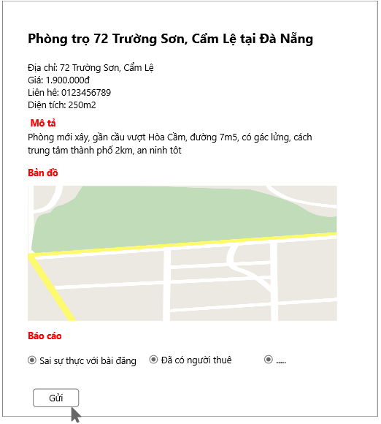

* 1. **User story S.14: Post to find roomate**

|  |  |
| --- | --- |
| Post to find roomate |  |
| As Renter  Renter want to earn more one or more people to stay with. They just click on the "Find friends" button, the form "Join" will be displayed. Users fill out information include:"Tên phòng", "Giá phòng", "Diện tích", "Thành phố","Quận","Huyện/Phường", "Địa chỉ". Once you have filled out the information, click the "Đăng tin" button and the post will be posted successfully | |

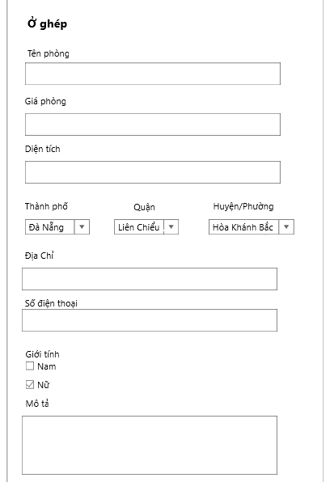

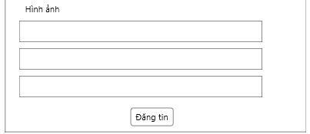

* 1. **User story 1.14: View detail about accommodation**

|  |  |
| --- | --- |
| View detail about accommodation |  |
| As Landlord  Landlords want to see the details of their individual places by clicking the "Chi tiết" button, the "Chi tiết" form will appear, including the details of each accommodation along with pictures of it. | |

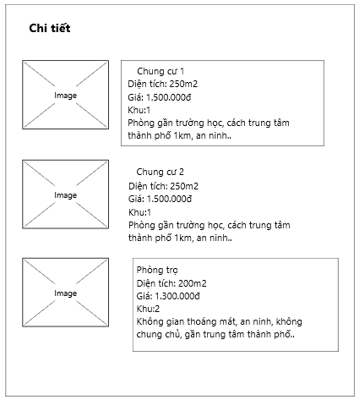

* 1. **User story 1.3: Create a new admin account**

|  |  |
| --- | --- |
| Create a new admin account |  |
| As an admin, after click on “Tạo tài khoản Admin”:   * Enter the informations in the form. * “Tên đăng nhập”: The user enters the name that they want to use in the system. That does not match the name that exists in the system, does not contain special characters and spaces. * “Mật khẩu”: user enter password for login. That password does not contain special characters, space, password can not be less than 6 characters * "Email" users enter their email. Email must conform to convention ten_e_mail@x_mail.com * "Số điện thoại:" the user enters a phone number whose phone number contains only the number, the telephone number must not exceed 15 characters. * Text boxes which have symbol “*” is not null. * Click on “Tạo” button to create a new admin account. * The screen display a message box to notice that account is saved in the system. * The user clicks on “OK” button. * Click on “Hủy” button to cancel and exit the form. | |

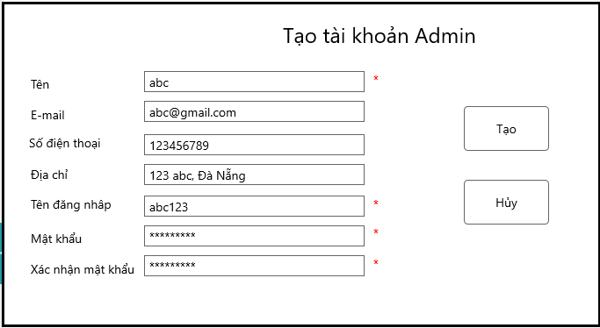

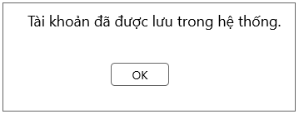

* 1. **User story 1.4: View customer reports**

|  |  |
| --- | --- |
| View customer report |  |
| * From menu of the interface * Select button of “Tìm kiếm theo giá”   The website will be show products by price | |